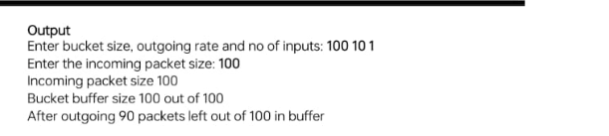
#include<stdio.h>
int main(){
int incoming, outgoing, buck_size, n, store = 0; printf("Enter bucket size, outgoing rate and no of inputs: "); scanf("%d %d %d", &buck_size, &outgoing, &n);
while (n != 0) {
printf("Enter the incoming packet size : "); scanf("%d", &incoming);
printf("Incoming packet size %d\n", incoming); if (incoming <= (buck_size - store)){
store += incoming;
printf("Bucket buffer size %d out of %d\n", store, buck_size);
} else {
printf("Dropped %d no of packets\n", incoming - (buck_size - store)); printf("Bucket buffer size %d out of %d\n", store, buck_size);
store = buck_size;
}
store = store - outgoing;
printf("After outgoing %d packets left out of %d in buffer\n", store, buck_size); n--;
}
}
1. Simulate various network using (LAN/WAN) and run the following commands
(1.Ping 2.ipconfig/ifconfig 3.Host name)
Answer : Ping 192.168.0.1
Ipconfig
hostname
2. Simulate various network using (LAN/WAN) and run the following commands
(1.Whois 2.Netstat 3.Tracert/Traceroute/Tracepath)
Whois command is not directly working for that we need to install software and change environment variable path so you just tell the mam this command is not working in the window directly or you can use another command
2. netstat
3. tracert www.google.com
Simulate various network using (LAN/WAN) and run the following commands
(1.NSlookup 2.ARP 3.Port scan/nmap )
Arp -a
1. nslookup
Nslookup www.yahoo.com

